Standard Operating Procedure: Required Tools & Resources

Document Control

- Project Name: Comprehensive Multi-Domain Penetration Testing Framework

- Team Members: Bhavya (Lead & Resource Procurement), Ayush (UI/UX & Reporting), Jigar (Backend & Testing)

- Document Version: 1.0

- Status: Operational Baseline

1. Objective
This SOP outlines all software tools, open-source scanners, libraries, frameworks, hardware, and environment resources needed to design, develop, test, and run the complete multi-domain penetration testing platform.

2. Multi-Domain Security Tools Stack (Backend Engine Integration)

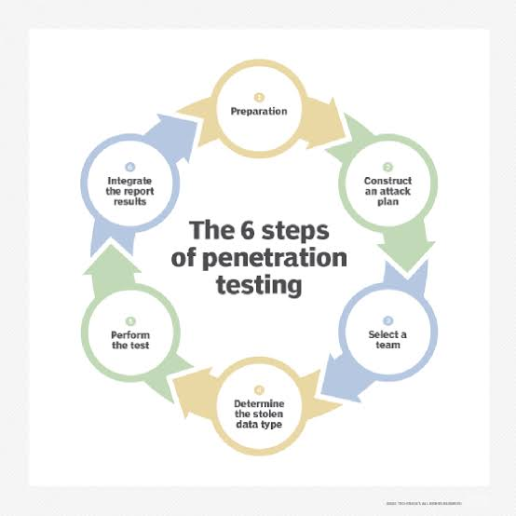

A. Network Penetration Testing
- Nmap / Libnmap: Host discovery, port scanning, OS fingerprinting, and service banner grabbing.

- Masscan: High-speed IP range and large-subnet asynchronous port scanning.

- OpenVAS / Greenbone: Open-source vulnerability scanner for deep host vulnerability checks.

- Wireshark / TShark: Packet capture analysis, protocol inspection, and PCAP parsing.

B. Web Application Security
- OWASP ZAP (Zed Attack Proxy): Automated vulnerability scanning (SQLi, XSS, CSRF, broken headers).

- Burp Suite (Community / API): HTTP request interceptor, proxying, and active/passive crawling.

- Nikto: Web server configuration, dangerous file/CGI detection, and outdated server component scanning.

- Nuclei: Fast, template-based vulnerability scanner for web endpoints and APIs.

- Sqlmap: Automated SQL injection detection and database takeover testing.

C. Mobile Application Security (Android / iOS)
- MobSF (Mobile Security Framework): Automated, all-in-one SAST/DAST framework for .apk and .ipa binaries.

- Apktool: Android application reverse engineering, manifest decoding, and resource extraction.

- JADX / CFR: Decompiling Android DEX files back to readable Java code.

- Androguard: Python library for static analysis and permission checking of Android binaries.

- Radare2 / Cutter: Binary analysis and reverse engineering framework.

D. Cloud Security Assessment
- Scout Suite: Multi-cloud security auditing tool for AWS, Azure, and GCP via cloud APIs.

- Prowler: AWS & Azure security assessment, compliance auditing, and public bucket exposure checks.

- TruffleHog / Gitleaks: Hardcoded secret, API key, and credential scanner in codebase and cloud config templates (Terraform, CloudFormation).

E. Wireless Network Security
- Aircrack-ng Suite: Wireless card monitor mode control, packet capture, and handshake verification (airmon-ng, airodump-ng).

- Kismet: Passive wireless network, device, and rogue Access Point (AP) detector.

- Wifite: Automated wireless auditor for WPA/WPA2/WPA3 network checks.

F. Physical Security & Log Audit
- Proxmark3 Client Tools / Libnfc: RFID and NFC card format parser and UID analyzer.

- Custom Python Parsers: Formats raw CSV/JSON logs from physical badge readers into risk scores.

3. Role-Specific Software & Infrastructure Stack

A. Bhavya (Project Lead & Resource Coordinator)
- Resource & Repo Management: GitHub / GitLab (repository architecture, secret management, CI/CD pipelines).

- Project Tracking: Jira / Trello / Notion (sprint planning, task tracking).

- API Testing & Integration: Postman / Insomnia (testing REST endpoints between frontend and backend).

- Hardware Setup:

  - External Wi-Fi Adapter supporting Monitor Mode & Packet Injection (e.g., Alfa AWUS036ACH / TP-Link TL-WN722N v1).

  - USB RFID/NFC Reader-Writer module for physical audit validation.

B. Ayush (UI/UX & Reporting Lead)
- UI/UX Design Tools: Figma / Penpot (wireframing, dashboard prototyping, asset design).

- Frontend Frameworks: React.js / Vue.js or Electron (for desktop application UI).

- Data Visualization Libraries: Chart.js / Recharts / D3.js (interactive risk charts, severity matrices).

- PDF & Report Generation Engine:

  - Puppeteer / Playwright (HTML-to-PDF rendering).

  - ReportLab (Python-based PDF layout builder) or jsPDF.

C. Jigar (Backend & Testing Engineer)
- Backend Runtime & Languages: Python 3.11+ / Node.js / Go (asynchronous task execution).

- Task Queue & Caching: Redis + Celery / RabbitMQ (handling long-running scans asynchronously without blocking UI).

- Database Management: PostgreSQL / SQLite (storing target profiles, scan histories, and report logs).

- Testing Frameworks: pytest, Postman API Runner, and Dockerized Vulnerable Lab Targets (DVWA, OWASP Juice Shop, Metasploitable 2/3 for backend validation).

4. Summary Matrix of Primary Tools
Area | Lead Tool / Framework | Primary Purpose | Responsible Role
Project Management | GitHub + Jira | Repository management & sprint tracking | Bhavya
UI & Visualization | React + Chart.js | Interactive dashboard & target input UI | Ayush
Reporting Engine | Puppeteer / ReportLab | PDF, HTML, and JSON report generator | Ayush
Backend & Queue | Python + FastAPI + Redis | Scan orchestration & async engine | Jigar
Network & Web Scan | Nmap + OWASP ZAP | Network discovery & web vulnerability audit | Jigar / Bhavya
Mobile & Cloud Scan | MobSF + Scout Suite | .apk/.ipa SAST & cloud API audits | Jigar / Bhavya

